Maintenance Manager
Release Notes v4.2.0.0

Contents
1 Document Control 3
1.1 Author 3
1.2 Document Summary 3
1.3 Document History 3
1.4 Reference documents 3
1.5 Distribution 3
1.6 Quality Assurance 3
2 Introduction 4
2.1 Pre-Requisites 4
3 Functional Changes 5
3.1 Work Order Form (MAI3800). 5
3.2 Roles 7
3.3 Product Option ACTIVECON 7
3.4 Product/User Option UPDCOSTCTR 8
3.5 Product Option NEGINTERIM 9
4 Log No. Summary 10

- Document Control
  - Author
Exor Development

  - Document Summary
This document provides information about functional changes and a list of all logs fixed in this release.

  - Document History

Document History
Revision | Date | By | Description
1.0 | 12-Feb-2010 | Exor Development | First Edition

  - Reference documents
None

  - Distribution
Exor Customers, Partners and Staff

  - Quality Assurance
Document Details
File | Prepared By
Maintenance Manager at v4.2.0.0 | Exor Development
Document Name | Reviewed By
Maintenance Manager at v4.2.0.0 | Mark Lowe
Version | Approved for issue by
1.0 | Colin Stewart
Date of Issue | Support Manager
26-FEB-2010 | Graham Anns

- Introduction
This document defines the changes made to the Maintenance Manager product at release v4.2.0.0 plus a list of all logs fixed in this release.

Unlike the “Maintenance Manager Installation/Upgrade Guide”, this document is specifically targeted at the Maintenance Manager end user. Therefore, if the recipient of this document is an IT person please ensure that it is forwarded on to the relevant end user(s).

This document does not comprehensively describe the functionality of Maintenance Manager, or act as a User Guide.

Please note that any data shown in example screenshots does not represent any Customer’s live data; it is test data set up by Exor.

After reading through this document, should you have any further Maintenance Manager training or Consultancy requirements then please contact your exor account manager.

  - Pre-Requisites

No pre-requisites at this release
- Functional Changes
This section outlines the functional changes made at v4.2.0.0
  - Work Order Form (MAI3800).

The BOQ Items block has been altered to:-

allow more of the Description to be displayed.

include Total Cost and Total Estimated Labour fields.

use the standard “Check All” and “Uncheck All” icon buttons.

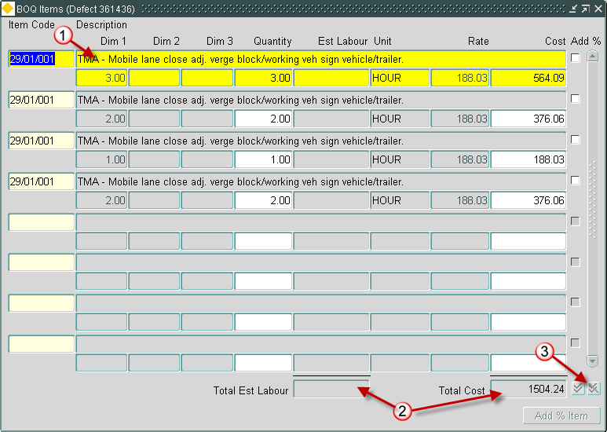

The BOQ Details canvas (accessed via the expand button whilst in the BOQ Items block) has been redesigned in order to present the information more clearly.
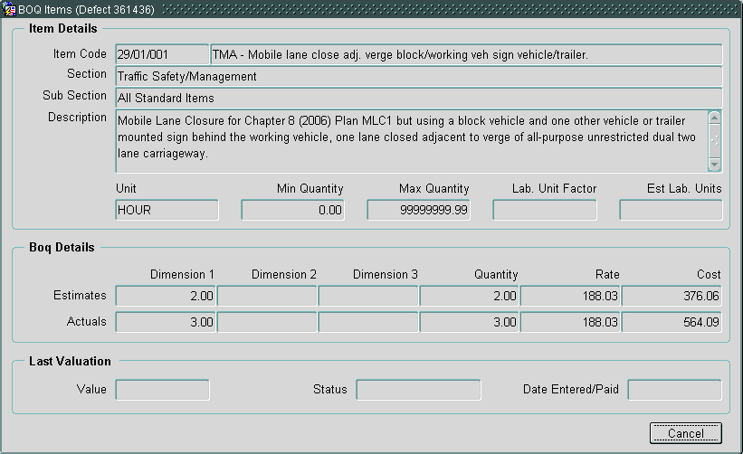

The Defect Summary canvas (part of Defect Selection) has been redesigned to:-
include Road Description.
include Defect Description.
make use of “Order By” buttons.
use the standard “Check All” and “Uncheck All” icon buttons.

NB. The “Order By” buttons can be used to order the list of available defects in order of the field that the button belongs to. However it should be noted that using these buttons re-queries the block so any ticks that have been placed against Defects to indicate that they should be included on the Work Order will be cleared.

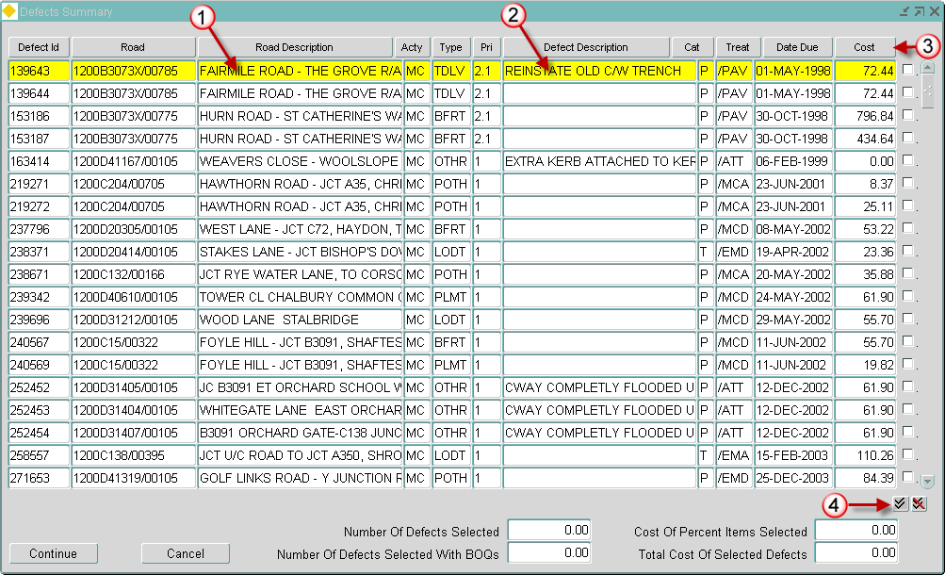

  - Roles

No changes at this release

  - Product Option ACTIVECON
This product option controls whether or not a user can select an inactive contract when raising a Work Order.

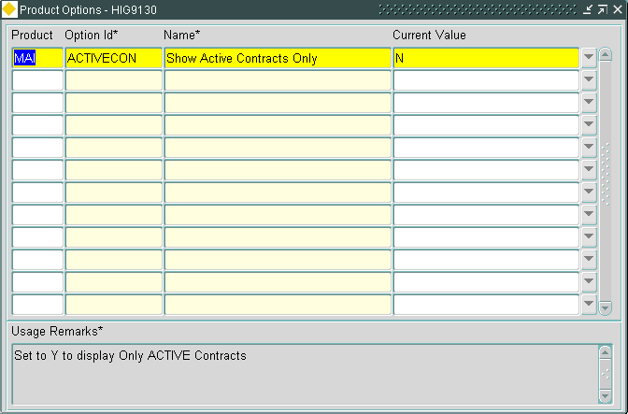

This product option has two values:-

Y = User can only select Active Contracts.
N = User can select both Active and Inactive Contracts.

The default value for this product option is N.

  - Product/User Option UPDCOSTCTR
This option can be specified at either Product or User level to determine whether all or specific Users can update the Cost Centre on a Works Order after it has been Instructed.

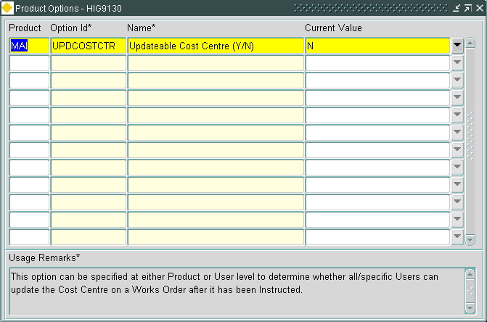

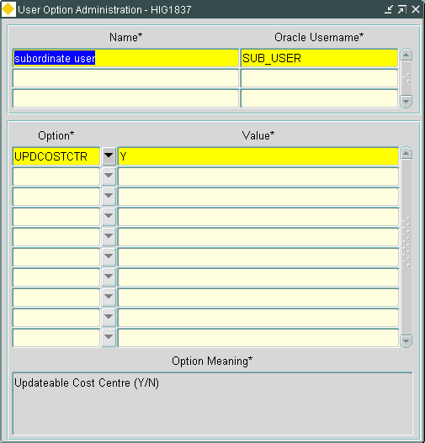

This product/user option has two values:-

Y = Users can update the Cost Centre at any point in the life cycle of a Work Order.
N = Users cannot update the Cost Centre after the Work Order has been Instructed.
.
In order to maintain the functionality of previous releases of the product the default value for the product option is N.

NB: If this Option is set up as a User Option it's value will override the value of the Product Option for the associated User.

  - Product Option NEGINTERIM
This option should be used to determine whether an Interim Claim (entered through the application i.e. not via the CIM Interface) should be allowed to reduce the value of a Work Order Line below the value of any previous payment(s).

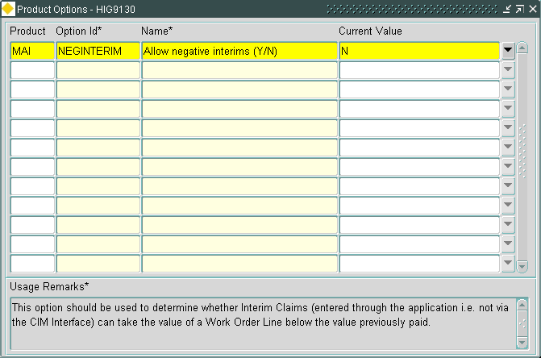

This product option has two values:-

Y = Interim Claims can reduce the value of a Work Order Line below the value of any previous payment(s).

N = Interim Claims cannot reduce the value of a Work Order Line below the value of any previous payment(s).
.
In order to maintain the functionality of previous releases of the product the default value for the product option is N.

- Log No. Summary
This chapter summarises all Software Changes (enhancements and new functionality) and Bug Fixes that have been made in this release.

These changes are derived from the following sources,

- Issues raised by Customers via Exor Support
- Issues raised internally by Exor

Internal Task ID | Issue | Support Call No(s)
0107298 | The Work Orders form (MAI3800) has been changed to correct a discrepancy between the Standard and Detailed BOQ LOVs (the Detailed one is used when Product Option STADETAIL is set to Y).  Previously the detailed LOV was allowing the selection of end dated Standard Items when a Work Order was assigned to the DUMMY contract, these then failed validation and an error was displayed to the User. | 710292
0107322 | The Work Orders form (MAI3800) has been changed to prevent the "Commit changes" message being displayed when the Work Order Line Status or Date Complete has been changed and the user presses the Commit button without first leaving the field. | 711530
0107328 | The Work Order form (MAI3800) no longer updates the Defect Status to STR_MAINT when the work order line status is changed to a code that does not require a change to the Defect Status. | 715050
0107354 | Added Road Description and Defect Description fields to the Defect Summary block in the Work Orders form (MAI3800).  This block now allows the user to impose ordering of the Defects, by clicking on the column headers.  NB: re-ordering of the block will clear the tick box used to select the Defects. | 716049
0107414 | When Percentage BOQ items are added at the Valuation stage in the Work Orders form (MAI3800) they no longer derive an estimated cost from the Parent BOQ as this impacts the Committed value of the Budget. | 718058
0107422 | In the Inspections by Group form (MAI3899) the Road Type LOV now includes all relevant group types. | 716791
0107444 | The Work Orders form (MAI3800) was not recalculating costs when the Contract was changed via the Contract Totals window. | 710076
0107758 | The Defects form (MAI3806) shows multiple Repairs for a Defect on the Summary screen.  This is correct, however the Repairs appeared to be Duplicates, so a Repair Category field has been added to highlight the difference i.e. Immediate, Temporary, Permanent. | 720742  712129  712180
0107806 | The Print Inventory Items Report (MAI2315) was showing incorrect asset details. It is now consistent with the results returned by the Assets form. | 717964
0108070 | In the Work Orders form (MAI3800):  A field containing Total Cost has been added to the bottom of the BOQ block.  The BOQ Description field is wider.  Layout of the BOQ Items expansion block has been redesigned. | 719715  709157
0108113 | When running Raise Work Order form (MAI3801) from Locator, both active and inactive contracts were shown in the LOV.  When the new Product Option ACTIVECON is set to Y, the Contractors LOV will only show active contracts. | 720597
0108141 | On the Work Order form (MAI3800), added a column in the BOQ block for Estimated Labour Units with a total at the bottom of the screen.  Parent BOQs are now ordered in BOQ_ID order i.e. the order in which they were entered by the User. | 719714
0108197 | Print Cyclic Maintenance Schedules (MAI3960) did not return any results if the product options USECYCGRPD and USECYCGRPL were not configured correctly. | 721896
0108286 | The Inspections form (MAI3808) should not allow users to change the priority of defects after they have been Instructed. | 722173
0108330 | Added a new Product Option NEGINTERIM. When set to Y, the Work Order form (MAI3800) will allow users to enter Interim Claims lower than previously paid claims. | 721236
0108544 | The Contractor Interface form (MAI3802) gave ORA-6502 error when querying back a work order line on a section with a long section description.
0108554 | The Work Order form (MAI3800) was not asking Users to commit a new Work Order before creating Lines if the Work Order Description had not been entered.
0108570 | When the value of Product Option DUMCONCODE is longer than 10 characters the Work Order form (MAI3800) was raising an error on startup.
0108576 | The Insurance Claims Report (MAI12790) now shows the Defect Status rather than the Repair Status. | 709834
0108629 | In the Defects form (MAI3806) the Date Instructed in the repair block should be derived from the work order Date Confirmed rather than the work order line Date Created. | 721916
0108680 | When the Road Section Historical Report (MAI3992) returns many defects for the same section, running over a number of pages, the defect details are formatted incorrectly.
0108713 | Expanded the Attribute Name field in the Correct Inventory Load Errors form (MAI2120).
0108803 | MAI3808 - Corrected an error that occurs if the User Name for 2nd Inspector is more than 26 characters in length. | 723708
0108814 | A new Product/User option, UPDCOSTCTR, has been created.  When this option is set to Y the Cost Centre on a Work Order can be updated in the Work Orders form (MAI3800) at any point in the life cycle of a Work Order.  NB: If this Option is set up as a User Option it's value will override the value of the Product Option for the associated User. | 723111
0108828 | Made the Work Order level Date Complete and Date Received fields non-updatable in the Work Order form (MAI3800) as it is not the intention that users should be able to update these fields directly.
0108866 | On Contractor Interface work order files (WO) the Financial Year was not being populated on record type 05. | 723753
0109083 | The Create Defect From Locator form (MAI3807) has been changed to allow the selection of appropriate Activity Codes when the Safety/Detailed Flag has been set to 'S' (Safety), the form previously only allowed the selection of the 'SI' Activity Code. | 724381
0109088 | Amended the Create Work Order From Locator form (MAI3801) to read the Product Option INCTOPCON which, when set to 'Y', allows users to select contracts associated with the top Admin Unit as well as contracts associated with thier own Admin Unit or lower in the hierarchy. | 724556

